Contributor: Alison Fraunhar

**Massaguer, Conrado**

Born Conrado Walter Massaguer: March 3, 1889 Cardenas, Cuba; Died: October 18, 1965 Havana, Cuba

Conrado W. Massaguer is remembered as the dominant force in graphic arts and popular periodicals in Cuba from the 1910s through the 1950s. During his long career, Massaguer created and published a number of magazines, including the highly influential *Social* and the widely popular *Carteles*. Citing Charles Dana Gibson and James Montgomery Flagg as influences, Massaguer developed a distinctive visual style in illustration and caricature, creating an instantly identifiable modernist look in his magazine covers and ads whose impact spread across Latin America. His sense of style extended to layout and content, modernizing and updating the Belle Epoque aesthetic previously dominant in Cuba. He was a founding member of the influential association of artists, writers and theorists, the *Grupo Minorista*, whose Saturday lunches drew leading national and international artists and intellectuals. In addition to his activities in Cuba, Massaguer was famous internationally as an illustrator and caricaturist, publishing caricatures and illustration in Vanity Fair, the New Yorker, and other American publications along with French and German magazines. He was active against the repressive Machadato, the regime of the dictator Gerardo Machado.

As a young boy, Massaguer began drawing cartoons for Yucatecan newspapers; his family had left Cuba in 1896 during the War of Independence (1895-1899) for exile in Merida, Yucatan, where there was a thriving Cuban exile community. After schooling at a military academy in the US, he returned to Havana in 1910 and opened his first advertising agency, Mercurio, followed by the magazine *Gráfico* in 1913, which he started with his brother Oscar. With *Gráfico*, Massaguer established the template that he followed in most of his publications: he designed the magazine covers and some of the illustrations, and his advertising agency supplied the artwork for the advertising. Thus, he singlehandedly controlled the aesthetics of graphic arts and publicity on the island for most of the first half of the twentieth century.

Nevertheless, it was with *Carteles* that Massaguer achieved national prominence. *Carteles* was published for forty years and along with *Bohemia* was one of the two most widely circulated weeklies publications in Cuba. It featured national and international current events, sports, cartoons, stories, poems and artworks, in addition to reviews, celebrity news, fashion and decorating layouts and editorials. While Massaguer’s work is featured on covers during the magazine’s early years, later, other prominent Cuban and foreign artists contributed cover art and by the mid-nineteen thirties the artist Andrés (Andrés Garcia) had began a decades-long run as *Carteles* premier cover artist, producing hundreds of iconic covers. If *Carteles* was the most popular Cuban magazine, *Social* was the most prestigious. A monthly, *Social*’s cover price was four time that of *Carteles* and the magazine was quickly recognized as the pre-eminent cultural periodical of its day, drawing leading artists, including Enrique Garcia Cabrera, Jaime Valls, José Manuel Acosta and **Mario Carreño**, the interior designer Clara Porset, along with intellectuals like Juan Marinello, Alejo Carpentier, Alfonso Hernandez Cata, Ruben Martinez Villena, Jose Z. Tallet, Pablo de la Torriente Brau and the historian of the city of Havana, Emilio Roig de Leuchsenring, to its pages.

In 1921, Massaguer organized the first *Salon de Humoristas*, an exhibition of illustration art, and from then on participated in national and international exhibitions. In 1923, he joined fellow artists and intellectuals of the *vanguardia*, by forming the *Grupo Minorista* (Minority Group) which met in famous Saturday afternoon lunches. Group members wrote essays and took to the streets to protest governmental abuse of power, censorship and repression; Massaguer was one of the founding members and signatories of the group’s anti-imperial, anti-corruption declaration, *Declaracion del Grupo Minorista*, written in 1927 and published in both *Carteles* and *Social*. For this bold move, *Social’*s offices were ransacked by government troops and Massaguer was forced into exile in New York. There Massaguer became well-known, socializing with artists, politicians and theatrical personalities, and contributing caricatures and illustrations to such publications as *Town and Country, Colliers, Vanity Fair, Redbook, the New Yorker* and *Life*. While in exile, he continued to direct his magazines in Cuba and with the fall of the Machadato in 1935, Massaguer returned to Cuba and restarted *Social* publishingit until 1938. His WWII caricature, *Doble Nueve* (Double Nine) depicting Adolf Hitler, Winston Churchill, Franklin D. Roosevelt and Benito Mussolini playing a game of dominoes (from whence the title comes) watched by Hirohito and Josef Stalin, was reportedly the most widely circulated political cartoon during the war years.

After WWII, Massaguer tried to recapture the prestige and prominence of *Social* in a new magazine, *Desfile* (1947), but times and tastes had changed and the magazine did not succeed. After this, Massaguer, older and in failing health, struggled to earn a living as a freelance illustrator and international correspondent. He was further marginalized after the triumph of the revolution in 1959, when he was perceived as out of step with revolutionary ideals; overly enthusiastic about America and the materialistic American way of life, Massaguer found increasing difficulty in getting work. He attempted to resurrect his formula of combining editorial and marketing in *Voy Bien, Camilo?* (*Am I doing OK, Camilo*?) a small book titled after a famous rhetorical question asked by Fidel Castro during a speech alongside the revolutionary hero Camilo Cienfuegos in which along with caricatures and portraits of Cuban revolutionary leaders and scenes from daily life, Massaguer inserted caricatures of *barbudos,* or bearded revolutionaries into ads for American consumer goods. *Voy Bien, Camilo?* was a critical and commercial failure, and Massaguer retired from public life for his remaining years. Virtually forgotten until the late 1980s, interest in his career was revived by an exhibit at the National Museum of Fine Art curated by Luz Merino Acosta. In 2011 Jorge R. Bermudez published an extensive critical biography, restoring Massaguer to his rightful place in the history Cuban visual culture.

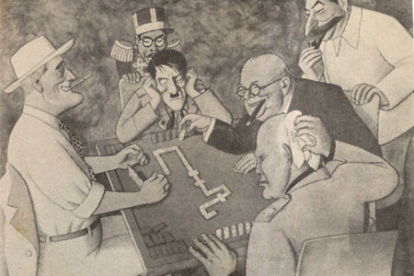

*Doble Nueve*, Conrado W. Massaguer, 1943

<http://librinsula.bnjm.cu/secciones/233/expedientes/233_exped_1.html>

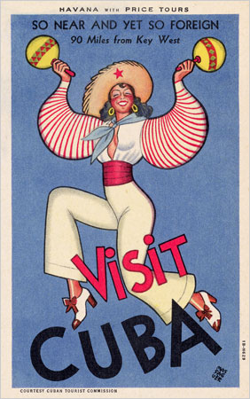

Postcard, *Visit Cuba* Conrado W. Massaguer, c. 1920

<http://wolfsonianfiulibrary.wordpress.com/2011/06/24/tourism-in-the-tropics-exploring-the-vicki-gold-levi-collection/>

**List of References and Further Reading:**

Marta Casals Reyes (2001-2002) “Conrado Walter Massaguer: artífice de la caricatura”, *Boletín del Archivo Nacional de Cuba*, La Habana, No. 13-14, , p. 198.

Jorge R. Bermúdez (2011) *Conrado W. Massaguer: entre la república y vanguardia,* Ediciones La Memoria, Centro Cultural Pablo de la Torriente Brau,La Habana

Conrado W. Massaguer (1957) *Massaguer. Su vida y su obra. Autobiografía, historia gráfica anecdotario.* La Habana

Fondo Conrado W. Massaguer, del Archivo Nacional de Cuba.

Luz Merino Acosta (1989) *Conrado W. Massaguer: Exposición homenaje en el centenario de su nacimiento*(Catálogo). Museo Nacional. Palacio de Bellas Artes, Ministerio de Cultura, La Habana.

Juan David (2002) *La caricatura: tiempos y hombres.*Ediciones La Memoria, Centro Cultural Pablo de la Torriente Brau, La Habana

<http://www.cubaliteraria.cu/monografia/social/galeria.htm>

**List of Works:**

Cover, *Social* Sept. 1931

Cover, *Carteles* Oct. 21, 1927

*Sobremesa Sabatical*, *Social* Feb. 1927

*Doble Nueve,* 1943

Cover, *Havana* Feb 19, 1929

Mural (untitled), Cuban Pavillion, New York World’s Fair 1938